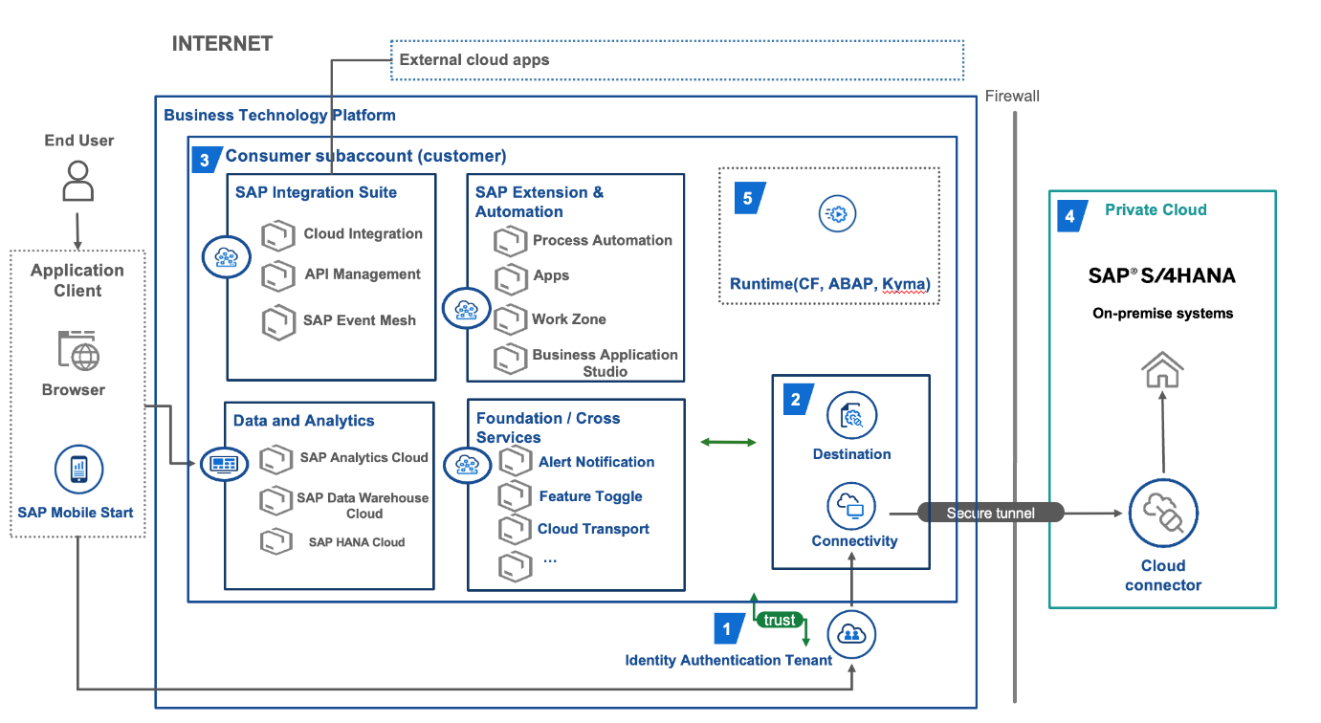
SAP BTP (Business Technology Platform)
SAP BTP is a cloud based Paas that Integrates tools for application development, data management, analytics, and automation.
SAP BTP Topography:
End User can use browser/mobile app to access the BTP cloud app.
Main BTP cloud Box (Centre) – SAP Integration Suite
CPI (Cloud Platform Integration) – Connects different system automatically. (e.g., It will connect SAP System like SAP BTP, SAP S/4 HANA, SuccessFactors with non-SAP systems like Salesforce, Workday).
API Management – Control app APIs securely.
SAP Event Mesh – Shares real-time events (data) between apps.
SAP Extension and Automation
Here we can build and automate the custom app on top of SAP Systems without changing the core code.
Process Automation – No-code bots/workflows for repetitive task
Apps (App development) – Build custom business app using low-code and deploy that to CF (Cloud Foundry), ABAP (SAP Style), Kyma (Microservice).
Work Zone – It’s like personlaized Dashboard – everyone see their own task in one dashboard.
(Manager: Sales KPIs + Team approvals
Worker: Shift tasks + Inventory check
IT: System alerts + New tickets)
Data and Analytics - Stores and analyses data
SAP Data Warehouse Cloud – Clean and reports big data.
SAP HANA Cloud – Super fast DB (Database)
Foundation
Alert Notification – Sends warning (email/SMS)
Feature Toggle – Turns app features on/off safely
Transport – Moves code between test/production
Connectivity (Bottom)
Connectivity Service – Manages secure links between BTP and outside system.
Destination Service – Stores connection details (like address/password) for app to use.
Identification Authentication Service (IAS) – Single login (like SSO) for users/apps.
Cloud Connectors – Safe tunnel from BTP to On-premises server
External Cloud (Top) - Other public clouds (AWS/Azure) connect to BTP
Private Cloud/On-Premise (Right Side)
Company's internal S/4HANA systems behind firewall. Cloud Connector links BTP to internal systems.

